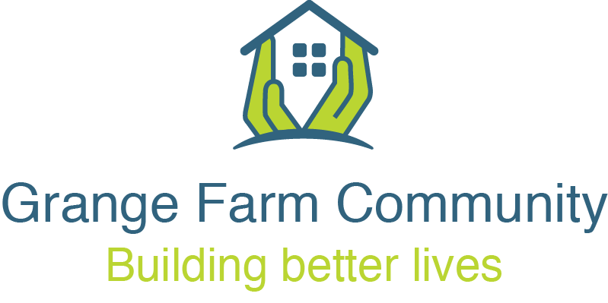
19.00 Thursday 30th September 2021
Steering Group meeting via Zoom
- Apologies, Declarations & Welcome

- Notes of meeting held on 25th August and 23rd September All
- Good News Stories All - Shivakuru, Local Hero Awards - Housing Design Awards Ceremony All
- Follow up on Anti-Social Behaviour (ASB) Natasha and Safer Neighbourhood Team Police

- Phase 1 Progress Update Mary - Update on Phase 2 & 3 contractor selection - Allocation to Phase 1, process and next steps Salome
(including kitchen choices)
- CPO position and next steps
- Starter Packs for moving temporary residents Rachel

- Follow up on Parking Control (PCM) & Signage All &
Sajjad Farid (Transportation)
- Higgins Update, including Social Value Joan / Amy
- Neighbourhood Agreement Nesan
- Community Development Update Rachel & Anthea
- Community hall use
- Allotment
- Date of the next full Steering Group meeting: 28th October 7pm

