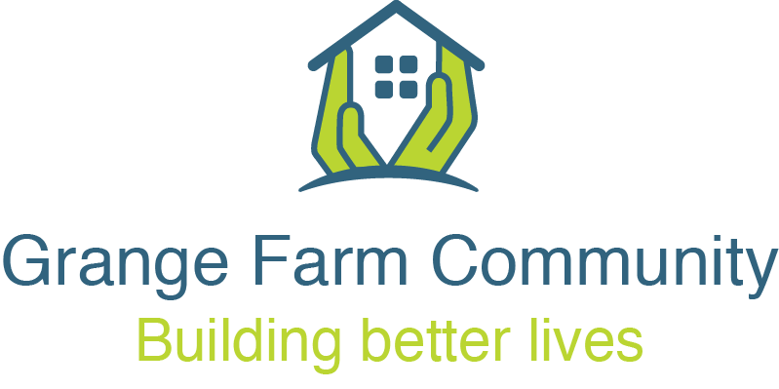

Steering Group Meeting Minutes
Date: Thursday 31st July 2025
Time: 7:00 PM
Location: The British Legion, 76 Northolt Road, South Harrow
Reminder: Individual repairs or personal issues should be reported via Access Harrow.

Attendees
Varsha Patel (Chair), Rekha Mehta (Vice Chair), Amita Jagai-Kempster, Erica Fontaine (Vice Chair), Frankie Reid (Vice Chair), Shivakuru Selvathurai, Shamim Manji, Denis Barker, V. Ranjan Narayanasamy, Sharleen O’Leary, Ashok Kotak (with Kamla), Aliya Ali, and Zainab.

London Borough of Harrow
Mary Hannington, Rita Contractor, Megan Zinkewich-Peotti, Cllr Mina Parmar (Portfolio Holder) and Cllr Stephen Hickman.

Charitable Outreach
Carol Sormaz (Roxeth Christchurch) and Rachel Dimond (MyYard).

ITA:
Raj Kumar and Casey Dalton.

Apologies
Shobhana Shah, Ken Woods, Kadra Hosh, Shaz Mohamed, Paddy Lyne (co-optee), Elizabeth Patterson, Kinnari Patel (LBH), Anthea Watkins (LBH) and Kulwinder Singh-Rai (LBH).

1. Declarations

None received.

2. Approval of Previous Meeting Notes held on 26th June 2025

Minutes agreed and available on the Grange Farm website: https://www.grangefarmsteeringgroup.co.uk

3. Good News Stories
- Community Intervention: Varsha Patel successfully prevented a large truck from entering the estate.
- Council Staff Recognition: Ade and Bill from Harrow Council were praised for their consistent responsiveness and for regularly checking in on residents.
- Celebration – Ken Woods:
Ken Woods, former Chair of six years, recently turned 90 and celebrated his 69th wedding anniversary.
Raj Kumar read out the following tribute:
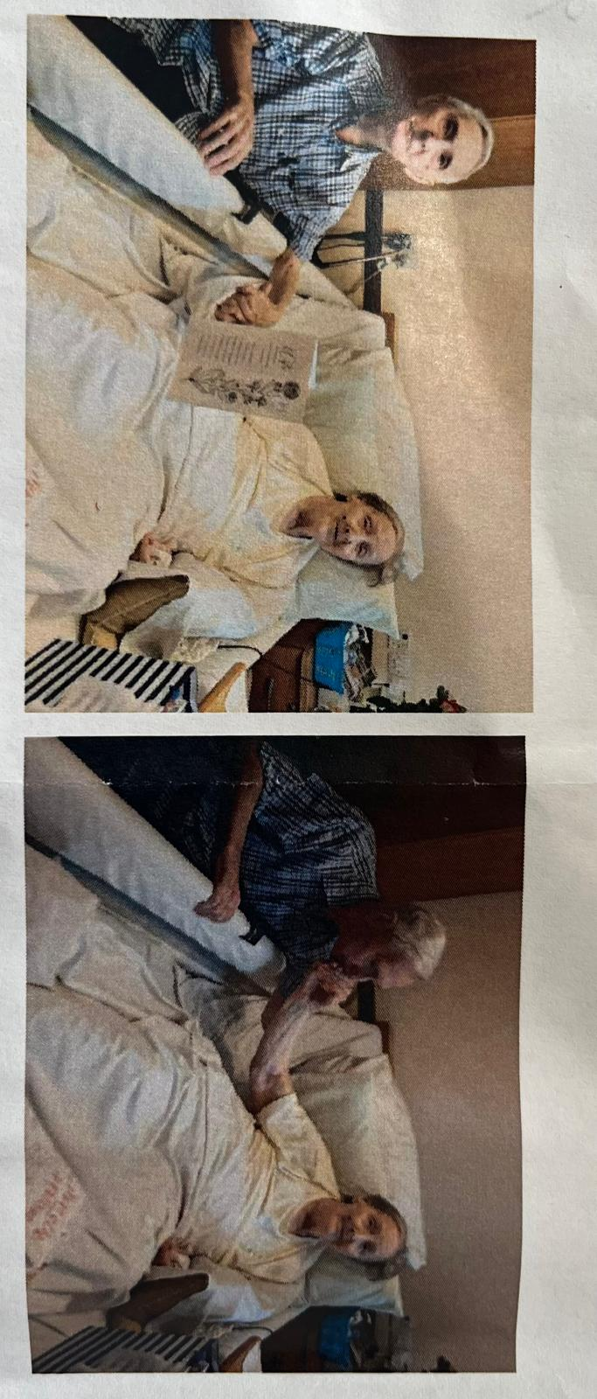
Mr. And Mrs. Woods at Appletree Court recently celebrated their 69th wedding anniversary, surrounded by warm wishes and quiet admiration from those around them. Sitting close together, their hands naturally finding each other's, they spoke with genuine affection and gentle humour about a life shared.
They had nothing but beautiful things to say about one another. "He's the talker," she said with a smile, her voice soft and kind. He grinned and added, "But she's the one with the beautiful voice, and the biggest heart. She always puts others before herself." When asked the secret to their long and loving marriage, they both agreed: patience and unconditional forgiveness. Simple words, but ones they've lived by for nearly seven decades.
Even now, there's a timelessness to their love, the way they look at each other, laugh together, and speak with a quiet understanding that only years of true companionship can bring. Their story is a beautiful reminder that love, when nurtured with care and grace, only grows stronger with time.”

4. R. Collard Update (Phase 2a demolition company)
Social Value Contribution: £10,000 + 50 volunteer hours
The following allocations were agreed:
- £2,000 – My Yard:
To support ongoing community initiatives, including the Food Market, Men’s Club (Tuesdays), Homework Club (Mondays and Tuesdays), and three hours per week of targeted support sessions for parents. These sessions focus on challenges such as English as a second language (ESL), trauma, special educational needs and disabilities (SEND), and cultural barriers.
Rachel emphasised that MyYard provides vital support to residents with complex needs, and this work is particularly valuable for vulnerable families in temporary accommodation who may be disproportionately affected by the upcoming demolition.
Additional training opportunities will be signposted through Voluntary Action Harrow.
- £1,000 – Roxeth Christchurch:
To fund a secure storage cupboard, arts and crafts supplies, and higher-quality board games—enhancing the experience for children attending community sessions.
- £3,000 – Allotments (legacy project):
For infrastructure improvements including polytunnels and storage. There is also interest in developing a peace or memorial garden as part of the space.
- £3,000 – Community Centre Improvements:
To support refurbishment and upgrades that benefit the wider community.
- £1,000 – Christmas Celebration:
To contribute towards the organisation of a festive event for residents.
Mary provided the following update.
On-Site Works
- Initial surveys are complete and strip-out works are underway.
- Demolition is scheduled to take approximately 5–6 weeks, beginning mid-August.
- Harrow Council is currently exploring the demolition of two additional blocks, subject to planning approval.
  - Action: Mary to follow up with R. Collard regarding the provision of out-of-hours contact information for residents as promised (by Iain Martin when he attended the meeting held on 29th May 2025).
Pest Control
- A detailed pest control strategy has been requested to accompany the demolition phase. This should include weekly inspections and baiting measures.
  - Action: Mary to confirm the pest control plan within the next week.
- Rat activity has already been reported in and around Wesley Close, and residents are encouraged to continue reporting issues.
  - Action: Mary to liaise with Harrow Council colleagues to explore the possibility of a centralised rodent reporting system.

5. Planning Committee Update (23rd July) – Mary
- Planning approval has been granted, allowing the project to move forward as scheduled.
- Particular emphasis is being placed on accessibility and the needs of vulnerable tenants in Phase 2A. Harrow Council will carry out a focused assessment of current needs and required adaptations, particularly in response to changing health conditions.
- The number of wheelchair-accessible ground-floor units will increase (from the current 5 homes) to reflect the evolving demographic and to better meet local needs.
- Salome will be visiting all residents to ensure individual needs are captured and addressed in the planning process.

6. Main Works Contractor Selection (Phase 2a – 45 homes) – Mary
- The tender process closes on 26th August, followed by a 2–3 week evaluation period.
- Three residents have been selected to join the Social Value Evaluation Panel, which will meet for a full day of presentations and engagement on 9th September 2025.
- Panel Members:
  - Elizabeth Patterson – brings experience and interest in social value through her work.
  - Varsha Patel – Steering Group Chair.
  - Erica Fontaine – Steering Group member and Warm Hub volunteer.
  - Denis Barker (reserve) – Steering Group and Kids Club.
- The contractor is expected to be appointed by October.
- Resident engagement will continue to be prioritised as the project progresses, including those moving into new homes.
- Design meetings will remain inclusive, and the proposed demolition of two additional blocks will not impact the existing design.
  - ACTION: Current layout plans to be shared; further detailed designs will be forthcoming.

7. Anti-Social Behaviour (ASB) & Safety Concerns – Rita
Key Issues:
- An unwell disruptive resident in Russet Court is being managed through a multi-agency approach. A court hearing is scheduled for October. The individual is currently in supported accommodation.
- Jake Jordan has been newly appointed as the Anti-Social Behaviour (ASB) Officer and is now handling several ongoing cases.
- Fly-tipping:
  - A recent large-scale incident was not captured on CCTV. Due to the professional nature and frequency of fly-tipping, recurrence is likely.
  - ACTION: Explore CCTV coverage options, especially given the single-entry access to the estate from Dudley Road. Also to consider the mobile CCTV service operated by the council.
  - Fly-tipping can be reported on the Harrow Council’s website or by clicking this link: https://www.harrow.gov.uk/streets/fly-tipping
- Cuckooing:
  - Rachel proposed that updated information on cuckooing should be shared with residents, including how to recognise signs and stay safe, particularly when neighbours may be experiencing acute mental health crises.
  - MyYard has previously worked with the founder of Safer Together to navigate similar situations.
  - ACTION: The Housing team to update and distribute advice to residents.
- Rough Sleeping & Drug Activity:
  - Reports of rough sleepers in shop awnings, Roxeth Recreation Ground, service roads, and bin stores/stairwells on Grange Farm. Activity appears linked to drug use.
  - Some rough sleepers attend local food markets, which could offer an opportunity for outreach.
  - Council's Rough Sleeping Outreach Team has increased capacity following a new appointment, but challenges remain around engagement and immigration status.
  - ACTIONS:
    - Request Jake Jordan to contact police for possible attendance at Steering Group meetings and a walkabout or estate inspections of the estate.
    - Again the Housing team and Jake Jordan to request police door-knocking sessions to reassure residents and provide safety advice.
    - Consider aligning police visit with the MP’s visit on 19th September, possibly alongside a Police Street Briefing.
ACTION: Rita and Meghan to follow up with Jake on feasibility of getting these items organised.
- Phase 1 Concerns:
  - Reports of cannabis use in the central courtyard area and the smell is a concern.
    - ACTION: Report to Rita, Housing Officer, who will arrange targeted visits. Rachel stressed that support, not just enforcement is needed.
- Other Issues Raised:
  - Uncollected blue bins:
    - ACTION: Request collection and follow-up. Raj to send Meghan details of the previous agreement held between “Housing” and “the Waste team” on collecting contaminated bins.
  - Abandoned vehicles suspected in drug-related activity have been reported to the police.
    - Additional reports can be made here: https://www.harrow.gov.uk/streets/abandoned-vehicles
  - Phase 3 (60 Osmond):
    - Decorating issues and foxes digging into the property. Resident has enquired about possible relocation.
    - ACTION: Ade to assess and take appropriate next steps around the repairing issues. Raj will send details of the previous reports made by the resident to Ade.
8. Upcoming Meetings & Events
- Next Steering Group (Residents Only):
Thursday, 28th August 2025, 7:00 PM – The British Legion
- Surgery – Gareth Thomas, MP:
Friday, 19th September 2025, 10:45 AM–12:45 PM – By appointment only.

