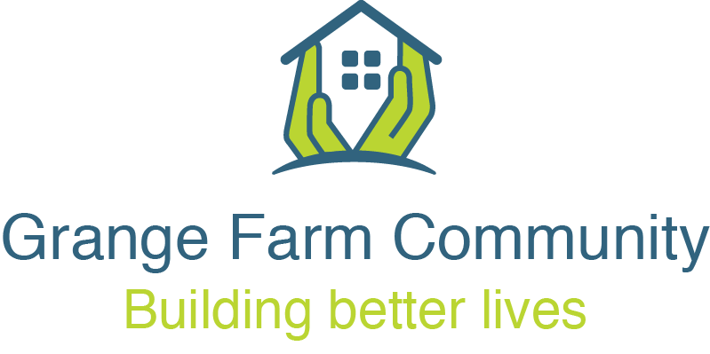
7pm Thursday 26th March 2026
Steering Group Meeting Agenda
The British Legion, 76 Northolt Road, South Harrow
Individual repair issues should be discussed with LB Harrow staff before or after the meeting.
Apologies and Declarations
Present:
Steering Group: Frankie Reid (Chair), Rekha Mehta (Vice Chair), Denis Barker (Vice Chair), V. Ranjan Narayanasamy, Amita Jagai-Kempster, Sharleen O’Leary and Elizabeth Patterson.
Residents: Denise Moore.
LB Harrow: Kinnari Patel, Anthea Watkins, Mary Hannington and Ade Ajibula.
MyYard: Rachel Dimond.
Roxeth Christ Church: Carol Sormaz.
ITA: Raj Kumar and Casey Dalton.
Thomas Sinden Ltd: Ray Mescall and Terry Floyd.
Met Police: Marshall Dabhi (PCSO)
Apologies: Varsha Patel (Chair), Erica Fontaine (Vice Chair), Shamim Manji, Shobhana Shah, Hafsa Begum, Kadra Hosh, Shivakuru Selvathurai, Alison Coudray, Paddy Lyne (Co-optee), Kulwinder Singh-Rai (LB Harrow), Sharon Strutt (LB Harrow), Billy Reid (LB Harrow) and Megan Zinkewich-Peotti (LB Harrow)

Good News Stories
- New signage – Grange Farm Crescent (expected May)
Megan has progressed this, with installation scheduled for May.
- Estate drop-in surgeries
Megan will reintroduce monthly drop-in housing surgeries on Wednesdays from 10:00–12:00 (15 April, 13 May, 10 June).
These sessions will give residents the opportunity to meet with the housing officer.
It was noted that weekday attendance may be limited. If this proves to be the case, a weekend session may be considered. There is also potential to link this with the Saturday Warm Hub.
- Visit from local MP (19 June)
The Steering Group welcomed confirmation of a visit from Gareth Thomas MP.
The visit will be by appointment only and will be publicised in the newsletter.
- New Housing Officer (Awudu Lamptey)
Although the scheduled estate walkabout did not take place, there was a strong turnout from residents, including some new faces.

- Estate inspection update
The estate inspection did not take place.
However, thanks were extended to Salome for door knocking and engaging with residents who should be the next group moving into Phase 2a.

Previous Meeting (26 February 2026)
The notes from the meeting held on 26 February 2026 were updated and circulated.

Update from Previous Meeting with Thomas Sinden Ltd (TSL)
- Project Plan
Ray (Operational Lead) and Terry (Resident Liaison & Social Value) attended from Thomas Sinden Ltd.
Main construction works are expected to commence in September, with completion of new homes anticipated between late 2027 and early 2028.
- Timetable & Consultation Methods
The design phase will run for 26 weeks, through to the end of July. The first two-thirds of this period will focus on resident consultation.
Engagement will include:
  - A series of 8–9 themed workshops (e.g. apartment layouts, metering, internal and external finishes);
  - An online portal and feedback spreadsheet for resident comments;
  - Online workshops/surgeries, with opportunities to engage every couple of weeks (April to mid-June); and
  - Face-to-face sessions, including a key session on TUESDAY 19th May 5pm – 7pm at the British Legion. This is a change from the original date proposed due to the local elections (pre-election restrictions).
A draft overall design document will be shared, and a “lessons learned” approach is being used to inform planning.
Key project team members include Adam Hill (Project Manager), Noel Farragher (Design Manager), James Strachen (Quantity Surveyor), and Andy Hill (Head of Design). Unfortunately, Andy Hill was unable to attend this evenings meeting.
It was agreed that, on 30 April, a resident engagement event should be held ahead of the Steering Group meeting. This will focus particularly on residents moving into the Phase 2A homes, while remaining open to the wider estate. The aim is to provide an opportunity for residents to contribute at a key stage.
The session is proposed to start at 5:00pm and will be advertised in advance, with a focus on listening to residents and sharing updates via the newsletter. Raj will coordinate the booking of the British Legion Hall.
A flyer and/or newsletter inclusion will be used to promote the drop-in session, including timings and contact details. It was also suggested that a short video or face-to-face engagement could support participation, and that translation services may be needed to ensure accessibility for all residents.

Residents will be kept informed at all stages.
Post Meeting Note : due to pre-election restrictions, the session on the 30th April cannot proceed. The Council will re-engage with residents after 8th May
- Visit to Existing TSL Scheme
A resident visit is being planned to an existing Thomas Sinden Ltd development at Morden Road (a 54-unit, two-block scheme and similar to Grange Farm is a phased development).

Thomas Sinden will require confirmation of attendee numbers and a proposed date before
arrangements can be finalised. It is hoped a visit might be planned for June.

- Design – Meet the Architect
Further opportunities will be arranged for residents to engage directly with the design team.
- Social Value
Terry outlined a package of social value commitments, including:
  - Training and employment support (CV writing, interview skills)
  - 16 hours of volunteering time
  - Community centre use and support for the Warm Hub programme
  - Access to online courses
These commitments will be monitored through internal Key Performance Indicators (KPI’s) and tracking systems, covering both borough-wide and estate-specific initiatives.
There is scope for further discussion and negotiation within the Re-Construction Service Agreement (PCSA).
A query was raised regarding inclusion of non-secure tenants.
Terry to follow up with a meeting with Rachel Dimond and other interested parties (My Yard/ Steering Group / Christchurch Roxeth / Harrow Council / Temporary Tenant representatives).
- Lessons Learned
The “lessons learned” document is being used to inform the design and engagement process.
4. Environment Improvement Programme (“Top Ten” Priorities Exercise)
A walkabout of the older blocks is scheduled for 10:30am on 14 April to help inform priorities for estate improvements.
Residents took part in a brainstorming activity and identified a range of priorities aimed at improving safety, maintenance, and overall quality of life across the estate. These are summarised below under key themes:

Outdoor Spaces & Environment
- Repair and enhancement of the play park, including addressing damaged equipment such as swings
- Continued efforts to monitor and reduce fly-tipping
- Improvements to the consistency of bin collection and general cleaning
- Review and potential removal of underused or redundant structures (e.g. storage sheds, bin stores)
- Addressing dropped kerbs and double yellow line concerns
- Repair of external areas, including filling gaps and addressing building surroundings.

Safety & Security
- Ensuring security cameras are installed and fully operational
- Repair or replacement of broken buzzer/intercom systems
- Exploring additional security options for vulnerable or non-secure residents (e.g. Ring doorbell systems)
- Improvements to estate lighting.

Housing Conditions & Maintenance
- Ongoing work to address damp and mould
- Opportunities to improve insulation
- Ensuring electrical safety issues are resolved
- Repairs to windows, including sealing and maintenance
- Addressing heating and condensation concerns
- Monitoring and addressing any structural issues.

Parking & Signage
- Reviewing signage to help reduce confusion and prevent unintended parking penalties, particularly near estate boundaries (e.g. Wesley Close).

Resident Engagement & Services
- Strengthening communication with residents, particularly ahead of works being carried out
- Continuing to improve responsiveness to day-to-day repair and maintenance issues.

Accessibility
- Identifying opportunities to improve accessibility across the estate for residents with mobility needs.

Summary
Residents expressed a shared ambition for a safer, cleaner, and well-maintained estate. There was recognition of ongoing work already taking place, alongside a desire to build on this through continued collaboration, improved communication, and targeted improvements to key areas of concern.

- Local Safety Parking Programme update
Kinnari advised that, regrettably, consultation on this matter cannot take place until after 8 May (Local Elections). This is disappointing, as consultation had been promised prior to the election.
Fly-tipping at the entrance to Wesley Close appears to be in the process of being resolved. The landowner has been contacted and has arrangements made for a skip to clear the waste.
- Annual General Meeting (AGM) (Thursday 29th October)
Details will be included in the newsletter. Raj commented on how valuable it is to have a co-chair and encouraged members to invite their neighbours to get involved. There will also be opportunities for new members to join the Steering Group.

- Community Development update
The newsletter will be distributed with all key dates included, and Anthea will ensure these are presented clearly. Plans are underway for a summer whole-estate BBQ with music, with Thomas Sinden having agreed to support this event. Consultations will also be incorporated as part of the event.
Additionally, a seaside trip or another annual event is being considered.
My Yard youth sessions continue on Mondays and Wednesdays, alongside Easter holiday activities. The men’s club takes place on Tuesdays.

Heritage Stories of Harrow funding is expected to be released soon, with a £10,000 allocation to capture and share stories (potentially of Grange Farm.)

The Roxeth Christ Church run Kids’ Club is running well, it was noted all attending families are currently in temporary accommodation. Activities include creating stop-motion films.

- The next meeting will take place at 7:00pm on Thursday, 30 April 2026 at the Royal British Legion.
There will also be a pre-meeting session for residents from 5:00–7:00pm to consult on the design proposals. Post Meeting Note : as above, this will be re-scheduled and the Council will re-engage with residents after 8th May

- Any Other Business (AOB)
Rachel and Raj will contact Superintendent Zubin Writer - to raise concerns about the increasing drug-related issues on the estate.

